Experiment No.1a: To design and implement a Schmitt trigger using Op-Amp for given UTP and LTP values & demonstrate its working.

Description:

Schmitt Trigger converts an irregular shaped waveform to a square wave or pulse. Here, the input voltage triggers the output voltage every time it exceeds certain voltage levels called the upper threshold voltage UTP and lower threshold voltage LTP. The input voltage is applied to the inverting input. Because the feedback voltage is aiding the input voltage, the feedback is positive. A comparator using positive feedback is usually called a Schmitt Trigger. Schmitt Trigger is used as a squaring circuit, in digital circuitry, amplitude comparator, etc.

Open loop gain of op amp is very high (ideally infinite).Any small difference between V_{NI} and V _{INV} results into saturation of output voltage ±V_{SAT} .Value of V_{SAT} is limited by the supply voltage of op amp

Components Required:
Op amp IC µA 741, Resistor of 10KΩ, 110KΩ, DC regulated power Supply, trainer kit

(+12v & -12v is given to Op amp from this),Signal generator, CRO.

Design:

From theory of Schmitt trigger circuit using op-amp, we have the trip points UTP= R2*Vref / (R1+R2) + R1*Vsat/(R1+R2)

LTP= R2*Vref / (R1+R2) - R1*Vsat/(R1+R2)

Where Vsat is the positive saturation of the opamp=90% of vcc

Hence given the LTP and UTP values to find the R1, R2 & Vref values the following design is used

UTP + LTP= 2R2*Vref / (R1+R2)-------(1)
UTP – LTP = 2R1*Vsat/(R1+R2)--------(2)

Let Vsat=12v, UTP=4v and LTP =2v then eq(2) yields R2=11R1 From Eq(1) we have Vref=(UTP+LTP)(R1+R2) / 2R2= 3.27v

Let R1= 10k then R2= 110k
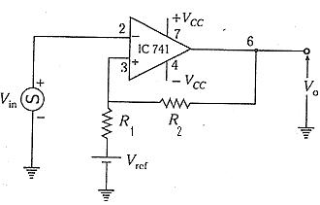

Circuit Diagram for Schmitt Trigger

Result waveform
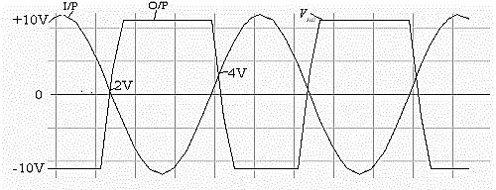

Hysteresis curve
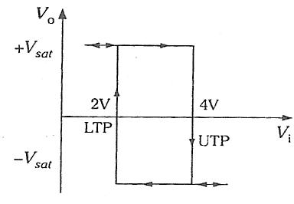

CRO in X-Y mode showing the Hysteresis curve

Experiment No.1b: To implement a Schmitt trigger using Op-Amp using a simulation package for two sets of UTP and LTP values & demonstrate its working.

Components to be placed in the schematic:
IC uA 741, Resistor of 10KΩ, 110KΩ, DC regulated power supply, Signal generator,

CRO
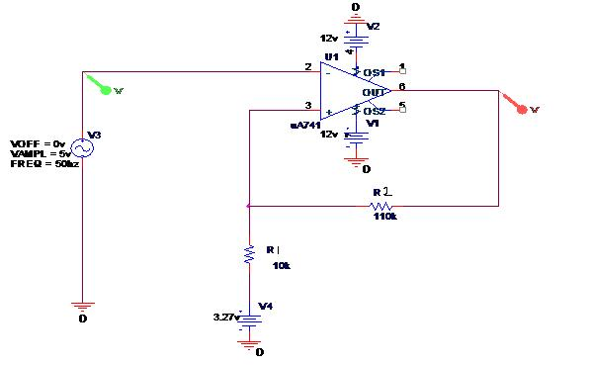

Type of analysis: TIME DOMAIN (TRANSIENT) Run to time: 100msec step size: 0.1msec

UTP=4v LTP=2v Vref=3.3v
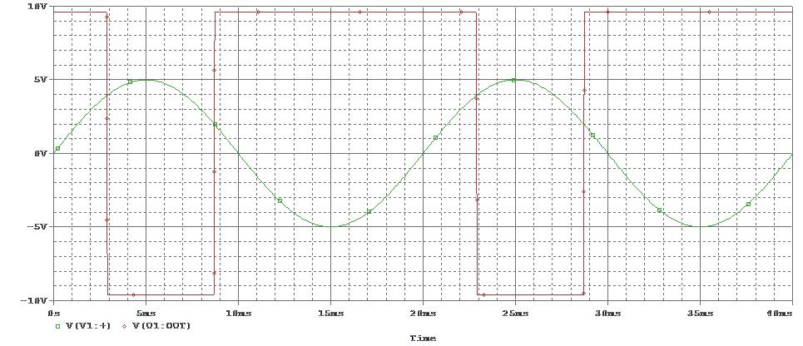

Hysteresis Curve:
To get the Hysteresis curve

- Choose Axis settings from Plot menu
- Under X-axis select axis variable
- Select the input wave
- Click Apply and ok
- From the output check the UTP and LTP values
- When Vin >UTP The o/p changes from +vsat(10v) to –vsat(-10v)
- When vin< LTP the o/p changes from -vsat(10v) to +vsat(-10v)

10V
5V
0V
- 5V
- 10V
- 5 . 0V | - 4 . 0V |  | - 3 . 0V | - 2 . 0V | - 1 . 0V | 0 . 0V | 1 . 0V | 2 . 0V | 3 . 0V | 4 . 0V | 5 . 0V
V(V1:+) |  | V(U1:OUT)
 |  |  |  |  |  | V(V1:+)
10V
5V
0V
- 5V
- 10V
0s |  | 5ms |  | 10ms | 15ms | 20ms | 25ms |  | 30ms | 35ms | 40ms
 | V(V1:+) | V(U1:OUT)
 |  |  |  |  |  | Time
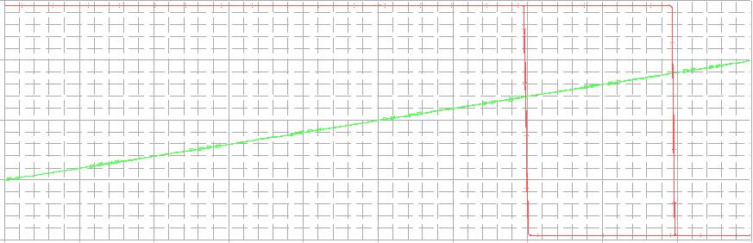
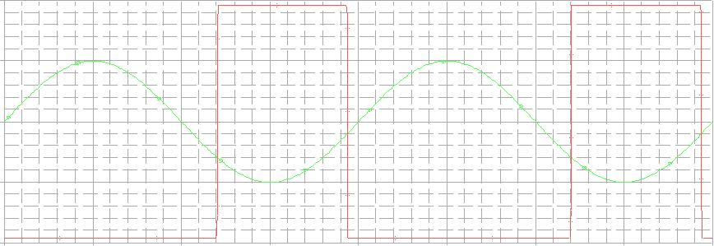
Hysteresis Curve
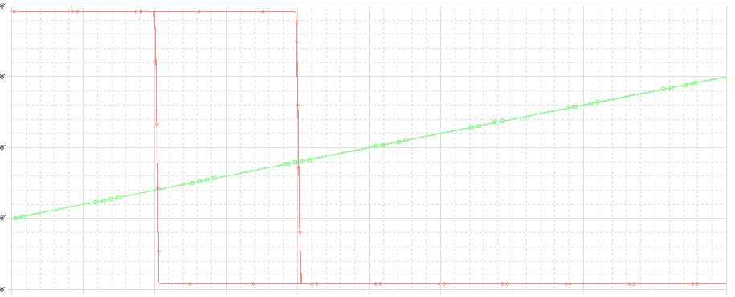

If UTP= 1V and LTP=-3V then Vref= -2.2v

For UTP=-1V LTP=-3V then Vref=-2.2v

